

**Chess club tournament**

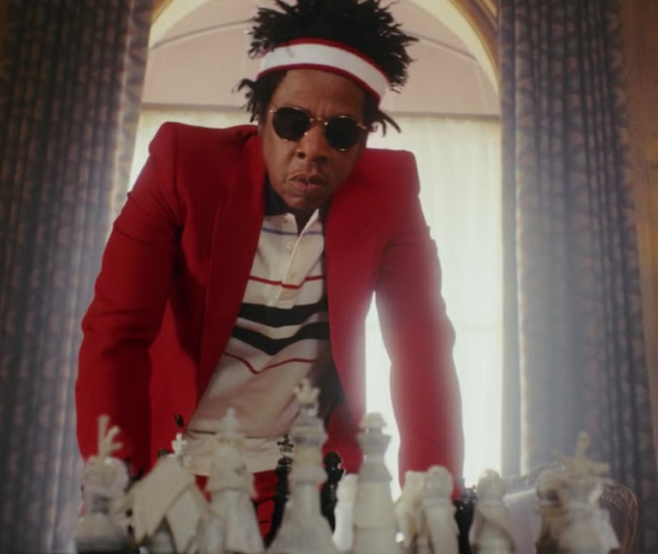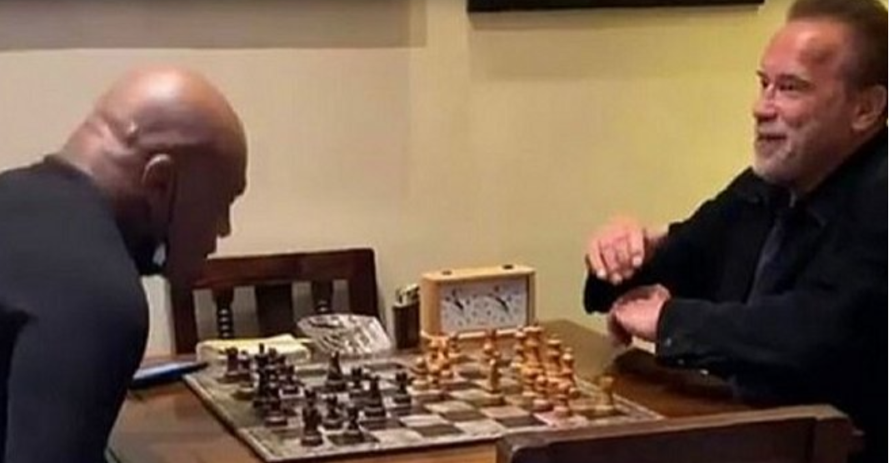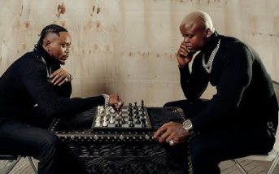

**Lots of stars enjoy playing chess, Jay Z was taught by his father who told him that life is like chess, you have to be completely aware in the moment, but also thinking a few moves ahead. Here is Mike Tyson and Arnold Schwarzenegger playing a timed game. Tanzanian singers Marioo and Harmonize also like to challenge each other to a game.**

**During chess club we have been playing games against each other in our own tournament and the stars of the tournament are…**

**1st place went to Naggib(year10), 2nd place went to Isaiah(year7)**

