**[BRAEBURN INTERNATIONAL SCHOOL]’s**

production of

**ALADDIN JR.**

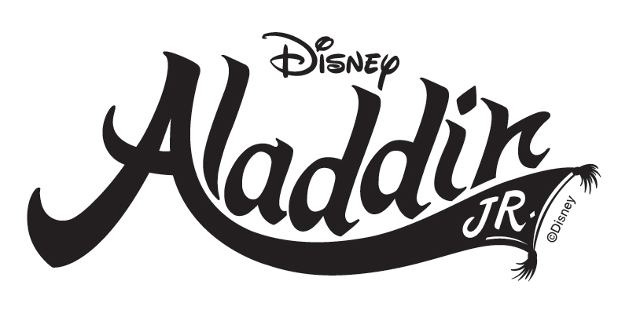

Music by

**Alan Menken**

Lyrics by

**Howard Ashman**, **Tim Rice** and **Chad Beguelin**

Book by

**Chad Beguelin**

Based on the Disney film written by

Ron Clements, John Musker, Ted Elliott & Terry Rossio

and directed and produced by John Musker & Ron Clements

Producer

**[Phil Treacher]**

Stage Director

**[Leah Gathoni]**

**[Mark Tunner, James Collingwood and Leah Gathoni]**

Music Director

**[Sekela Thambikeni and Leah Gathoni]**

Disney’s *Aladdin JR.* is presented through special arrangement with and all authorized materials are supplied by

Music Theatre International, New York, NY

212-541-4684 mtishows.com